Thank you for your interest in the Midnight Mission we are pleased to have you as a volunteer
Your service/tour will start at 11:00 a.m.

For your convenience we have supplied you with a map of the general area and a parking pass for the day. Please pull into the underground parking located at 601 So. San Pedro St. and check in with the parking attendant, you will be directed where to park.
The parking pass must be posted in clear view on the dash board of your vehicle.

Please let us know via e-mail in advance at mlee@midnightmission.org if you would like a tour of our facility.

Please check in with security booth. Sign in and the security Officers will call me or a Public Affairs Assistant. Thank you again.

We hope that your visit will be both enjoyable and educational.


TEMPORARY PARKING PASS
Thanksgiving Celebration
November 22, 2007

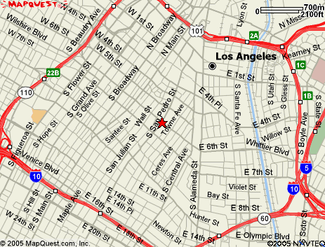

We are located at: 601 So. San Pedro St.
Los Angeles, CA 90014

The Mission is on the corner of 6th and San Pedro St.

